Computer Language Coding Concepts

Class Referrers in a Diagram
< The notation of a reference to an object reference’s class needs to be determined in the future. >

The concept of class referrers was explained in the article Class Referrers.

Because the concept of referrers simply also functions as the concept of class referrers, it can be displayed in a diagram the same way, except, that classes and class references are displayed with dashed lines.

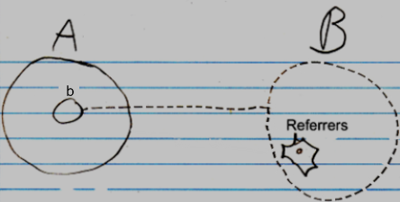

The reference line of the item in the Referrers list is displayed, then it has to point to the class redirection of symbol b. There is no final notation yet for a to something else’s class. But a preliminary notation could either be a reference to the Class inside b’s system interface:

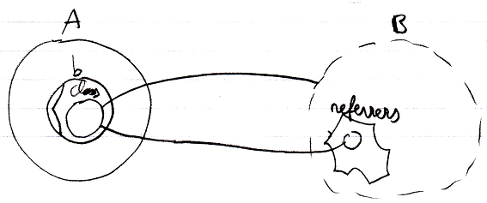

Or a reference line connnected to b’s class line:

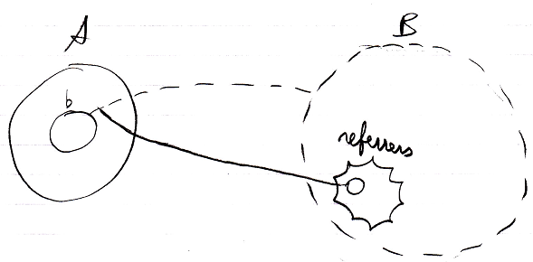

The referrers are pointed at by solid lines, because they are just references to the objects, that use it as a class. No implicit notation of making the referrer lines dashed will be used here, because that will introduce too much ambiguity in the diagram notaiton.

As mentioned in the article Referrers, it is not clear yet under which circumstances the whole referrers list might be completely left out of the diagram.

If a class defines that its objects support Referrers, but the class itself won’t register its Referrers, then the Referrers list of the class will be drawn out with dashed lines.

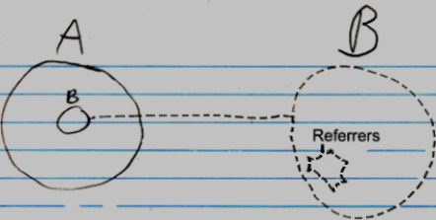

Obviously, the inactive referrers list will not contain any object references.

See also: Class Referrers, Referrers in a Diagram

Author & Copyright: Jan-Joost van Zon Date: June 15, 2008 – August 17, 2008 Location: Oosterhout, The Netherlands Status: Under Construction

